**LCD**

LCD (Liquid Crystal Display) screen is an electronic display module and find a wide range of applications. A 16x2 LCD display is very basic module and is very commonly used in various devices and circuits. These modules are preferred over [seven segments](http://www.engineersgarage.com/content/seven-segment-display) and other multi segment [LED](http://www.engineersgarage.com/content/led)s. The reasons being: LCDs are economical; easily programmable; have no limitation of displaying special & even [custom characters](http://www.engineersgarage.com/microcontroller/8051projects/create-custom-characters-LCD-AT89C51) (unlike in seven segments), [animations](http://www.engineersgarage.com/microcontroller/8051projects/display-custom-animations-LCD-AT89C51) and so on.

A **16x2 LCD** means it can display 16 characters per line and there are 2 such lines. In this LCD each character is displayed in 5x7 pixel matrix. This LCD has two registers, namely, Command and Data.

The command register stores the command instructions given to the LCD. A command is an instruction given to LCD to do a predefined task like initializing it, clearing its screen, setting the cursor position, controlling display etc. The data register stores the data to be displayed on the LCD. The data is the ASCII value of the character to be displayed on the LCD. Click to learn more about internal structure of a [LCD](http://www.engineersgarage.com/insight/how-lcd-works).

**Pin Diagram:**

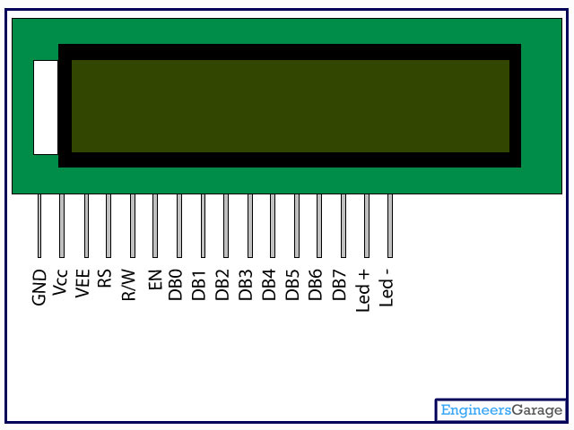

**Pin Description:**

|  |  |  |
| --- | --- | --- |
| **Pin No** | **Function** | **Name** |
| 1 | Ground (0V) | Ground |
| 2 | Supply voltage; 5V (4.7V – 5.3V) | Vcc |
| 3 | Contrast adjustment; through a variable resistor | VEE |
| 4 | Selects command register when low; and data register when high | Register Select |
| 5 | Low to write to the register; High to read from the register | Read/write |
| 6 | Sends data to data pins when a high to low pulse is given | Enable |
| 7 | 8-bit data pins | DB0 |
| 8 | DB1 |
| 9 | DB2 |
| 10 | DB3 |
| 11 | DB4 |
| 12 | DB5 |
| 13 | DB6 |
| 14 | DB7 |
| 15 | Backlight VCC (5V) | Led+ |
| 16 | Backlight Ground (0V) | Led- |